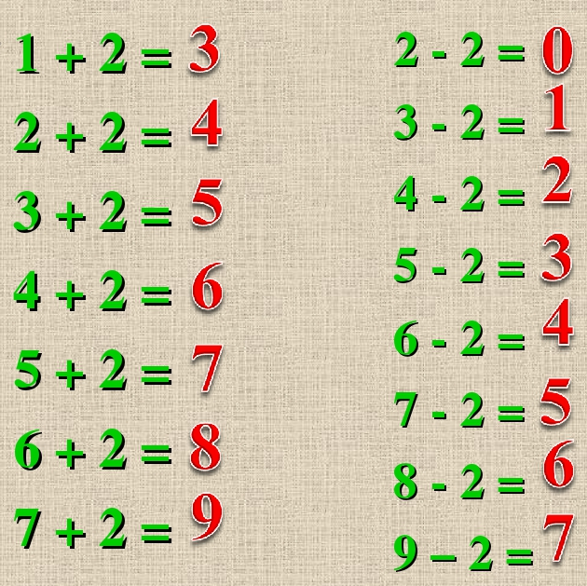

1+3=
2+3=
3+3=
4+3=
5+3=
6+3=
7+3=
3-3=
4-3=
5-3=
6-3=
7-3=
8-3=
9-3=

